**Dimension(EON) | Progress Report — October 2019**

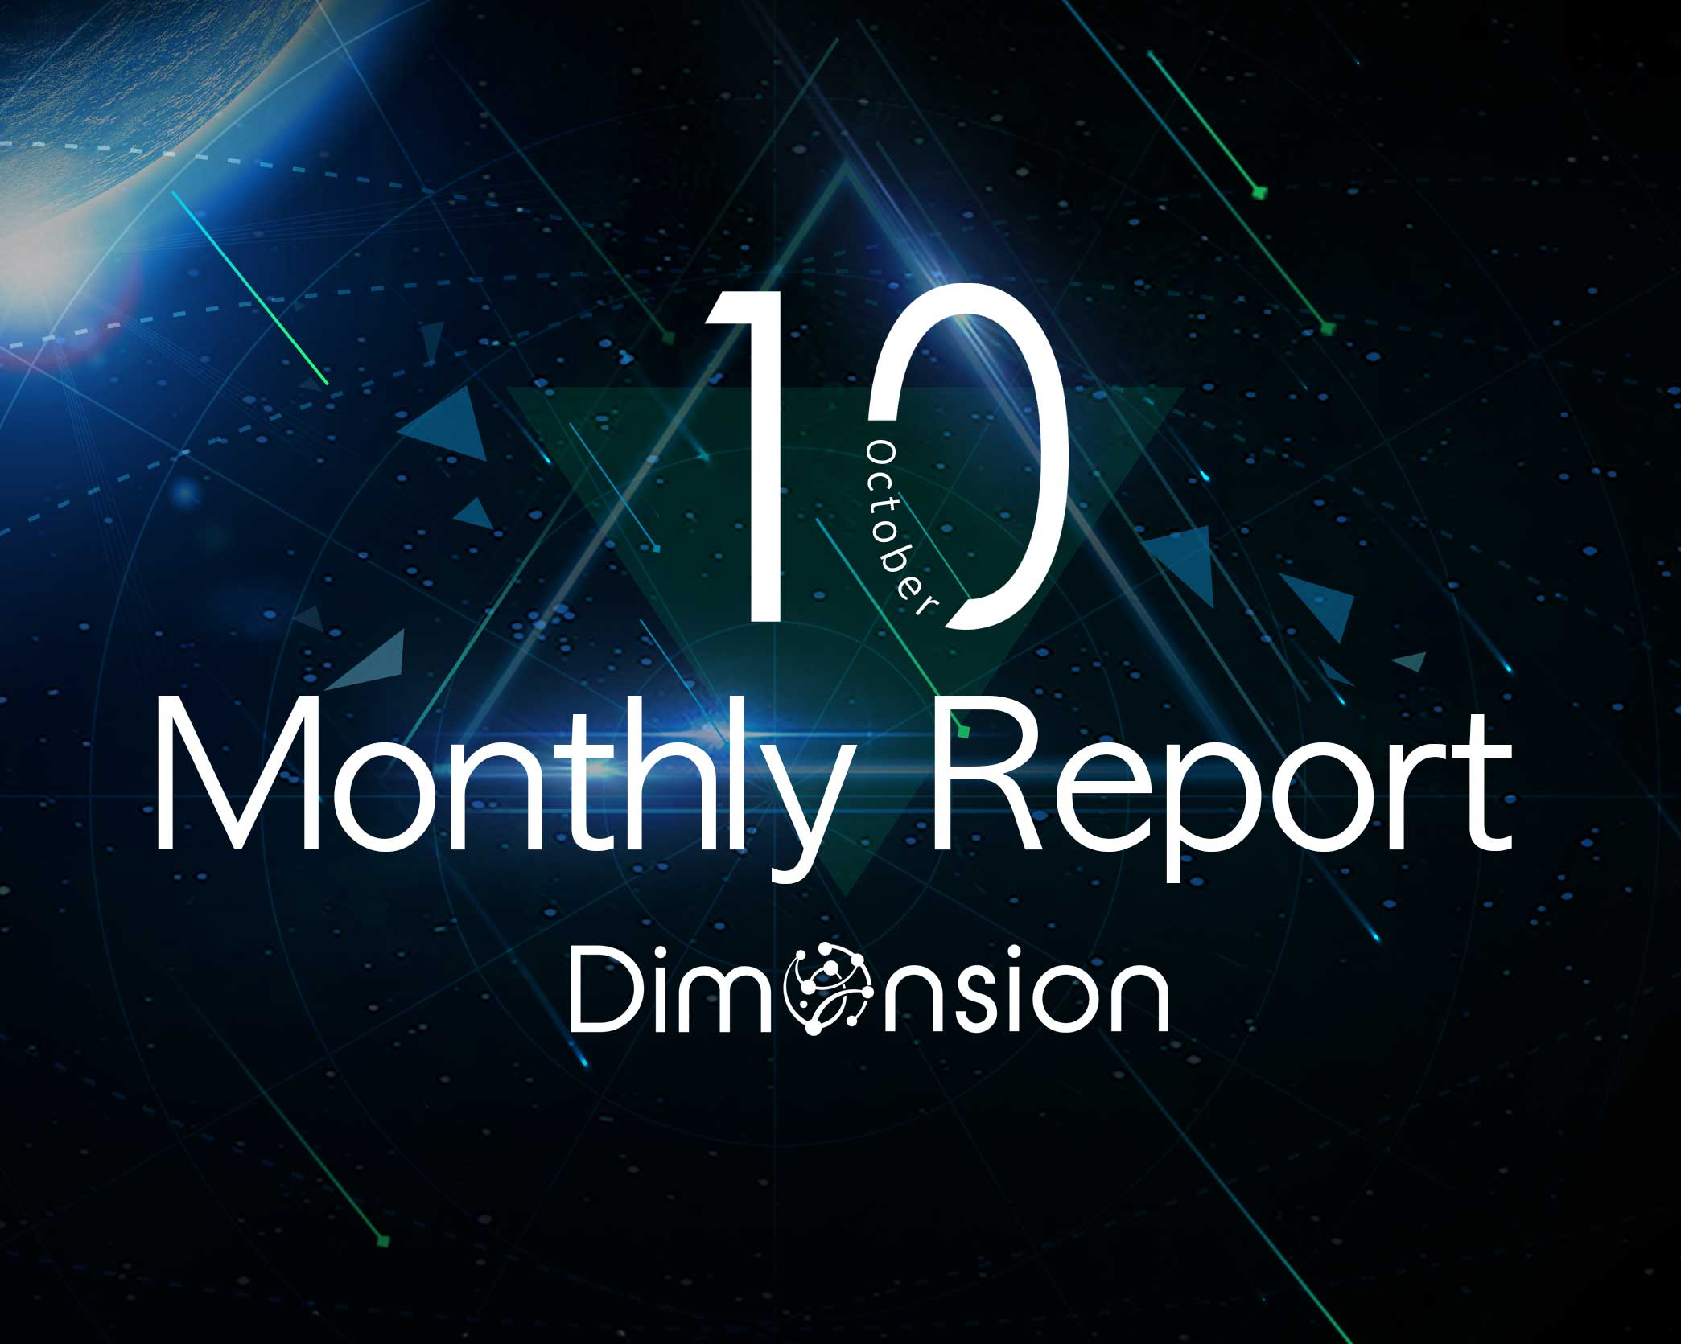

* **Technical Progress**

**1. Test work of the internal test-net started**

Code synchronization is completed

The authentication node permission is obtained

Create a proposal and apply to become a governance node

Verify voting and review proposal status

Execute the proposal, verify the work of the producer node

**2.Dynamic Node is successfully tested on test-net**

Governance node’s proposal application passed

Verification of the proposal voting process passed

Verification of the governance node participating in synchronous block production passed

The proposal to remove the producer node and the execution verification passed

**3.ConsensusX framework completed**

ConsensusX framework loaded pre-made algorithms and performed joint debugging of customize algorithms

Modify BUG and optimize interface performance

ConsensusX framework loaded internal test-net

**4 HPoS algorithm is basically completed, ready to start self-test**

Pre-research on HPoS-R algorithm based on HotStuff is completed

RBFT conducts Byzantine fault-tolerant first round of performance testing